
Frequently asked questions about the use of Manual Wheelchair

- Fasten the lap belt and prevent from falling forward when sitting
Correct sitting posture can prevent from sliding forward. If the user often slides forward when sitting on the wheelchair or even slips off due to reasons such as weak torso muscles, wanting to reduce the pressure on the hips from sitting for prolonged time, or habitual poor posture, then please use the safety lap belt!
- User Instructions
  - Firstly, make sure the user's torso is pushed right to the back of the wheelchair seat (meaning, there should be no gap between the body and the backrest or the seat), and maintain an upright sitting position.
  - Next, fasten the lap belt to the pelvis area at a 45-degree angle to the seat surface (see Picture 2 below). The lap belt should be tied close to the pelvis so that the pelvis is close to the back rest to prevent the user's hips from sliding forward.
  - If the user cannot control their body well, a chest strap can be added for extra support.

- Special conditions: If the user has conditions such as abdominal wounds or colostomy, pressure should be avoided on the area. If a snap-fastening strap is used, then the buckle can be adjusted to sit on the side to avoid the area.
Picture 1: Without lap belt | Picture 2: fastened with lap belt
 | 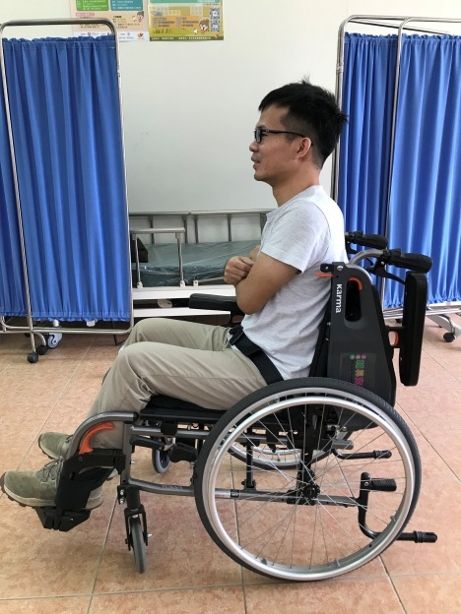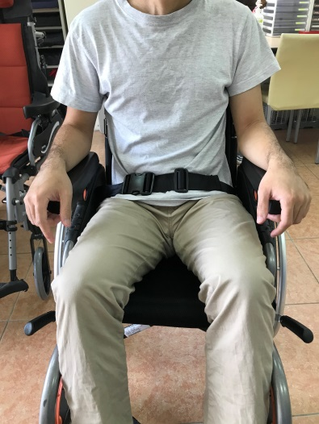  45。

- Additional function A of the wheelchair, making the act of transferring positions much safer and more convenient.
When the user cannot walk on his own or cannot even step out when assisted, the additional function A of the wheelchair (flip-up armrests and detachable footrests) can be used to improve the convenience and safety when transferring the user.
- Method of use: align the wheelchair sideways beside the bedside, adjoining the bedside. Lock the brake, and lift and pull back the armrest close to the bedside, and remove the footrest before assisting the user to transfer them to the bed or wheelchair.




