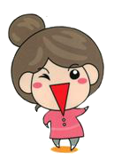
Frequently asked questions on the use of wheelchair seat cushions
- Function of a wheelchair cushion: When sitting down, the user will be in contact with the seat cushion from the buttocks to the thighs, and pressure is dispersed on the contact points. This will allow the user to maintain a stable posture, avoiding sliding forward or sitting in a deviated posture. This will reduce or prevent the occurrence of bedsores, and will also assist in maintaining a good sitting posture.
～Below are examples of common wheelchair seat cushion types, explanation of how they are used and ways to maintain them～
Name of assistive device | Wheelchair Seat Cushion - Type B  [Air inflatable seat cushion - rubber material] | 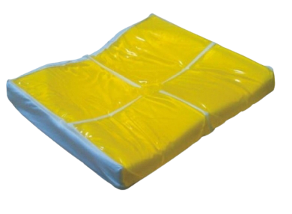  Wheelchair Seat Cushion - Type C  [Gel foam seat cushion]
Direction of placement | 1. Position the cushion and the cushion cover according to the direction indicated: up, down, front, back  2. The air cells face upwards and the inflation valve faces outwards  *One side of the cushion cover is non-slip, place it face down  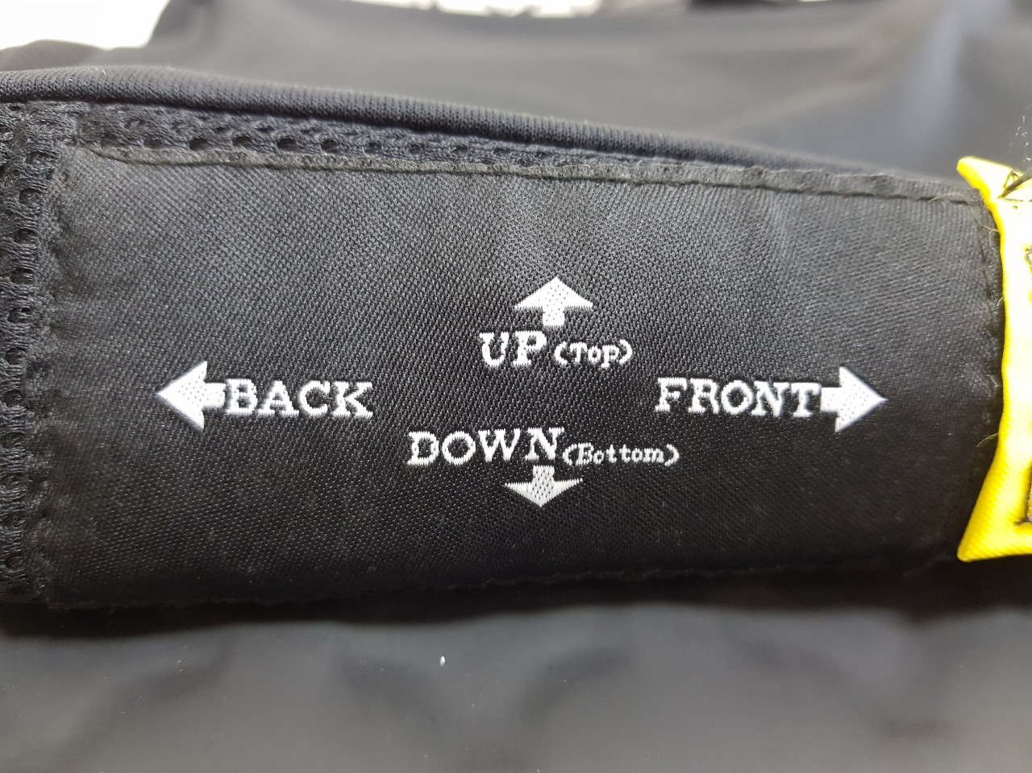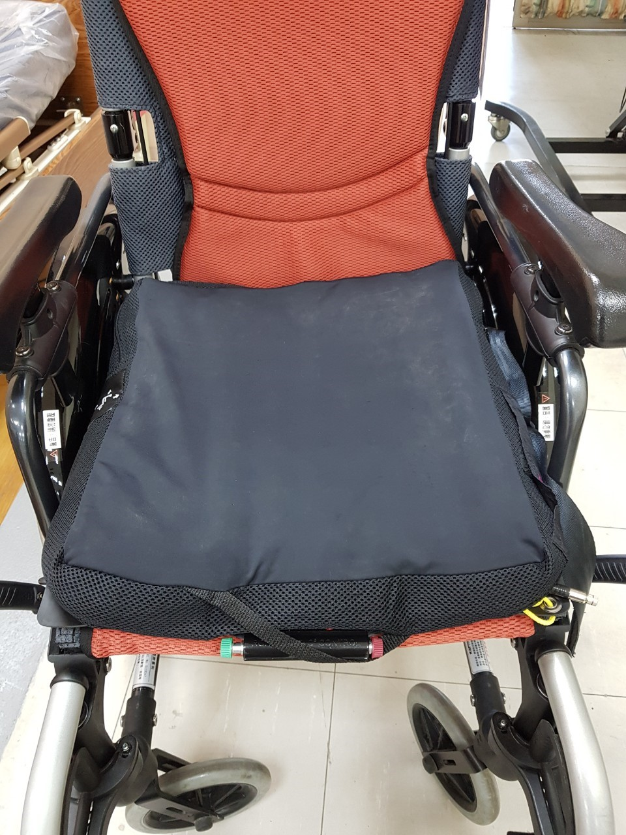 | Gel foam side up  *One side of the cushion cover is non-slip, place it face down  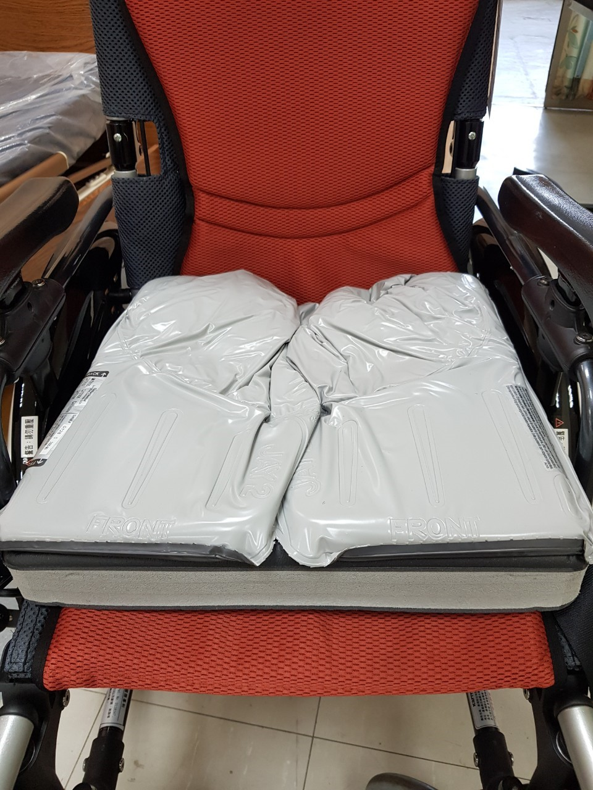
Method of maintenance | 1. Open the inflation valve counterclockwise. Once pumped up to about 70% full, lock the inflation valve by turning clockwise.  2. When the user is sitting down on the cushion, the caregiver should insert their hand between the seat cushion and the most protruding part of the hip bone (sit bone), with palm facing down.  3. Slowly turn the inflation valve counterclockwise to allow the user to sink into the seat cushion.  4. Lock the inflation valve clockwise when the caregiver feels that their hand is about to touch the bottom of the seat cushion.  5.The seat cushion should be checked and adjusted to reach adequate gas volume daily before use. | Push the clustered liquid gel back so that they are distributed evenly.
Cleaning and maintenance | Please wipe with a soft cloth moistened with a mixture of warm water and neutral detergent. Place the cushion in a cool place to dry, and avoid direct sunlight.
Caution | 1.Avoid getting pierced or cut by sharp objects.  2.The material is easily deformed and damaged by sunlight. Avoid exposure to the sun.

