Chiayi County Assistive Device Resources Center
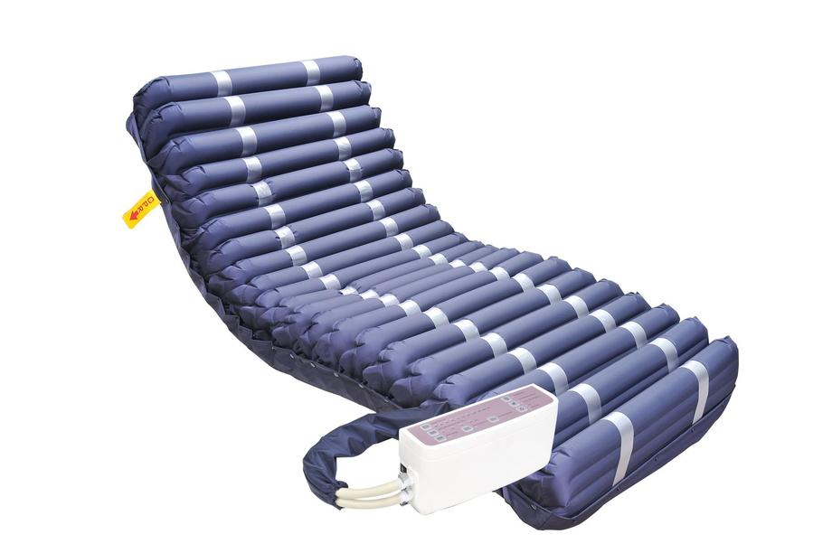
Instruction for Air Cushion Mattress
Fg.1
Top
Bottom
C.P.R. Rapid Vent Valve
Host and Connection Pipe
- Function: Prevent bedsore caused by limb pressure in long-term bedridden patients.
- Product Specifications (There are differences according to different brands)
- Power: AC120V/60Hz,0.1A.
- Size: 200×90×20cm.
- Maximum load: 180 kg.
- Circulation time: three tubes alternately circulate
every 8 minutes.
- Others: equipped with C.P.R. rapid vent valve.
- Steps to Use:
- Place the air cushion mattress on the mattress,
and place the end of the air-filled tube at the end of the mattress (Fig. 1).
- Fix the four-corner elastic belt at the base of the air cushion mattress.
- Insert the connecting pipe of the air cushion mattress into the pump outlet and check whether the pipeline is smooth.
- Hang the host on the board at the end of the bed and plug it into the socket (110V). It is recommended to plug it in for 24 hours.
- Turn on the power and transfer the pressure value to the maximum to inflate it.
- When all pipes are filled with gas (about 30 minutes), check whether the host shows normal pressure, adjust the pressure according to the user’s weight, and adjust the alternating mode so that the user can lie down and use it.
- If not in use, remove the power supply, connection pipe and C.P.R. quick vent valve to deflate, and then crimp or fold them for storage after deflation.
- Precautions:
- Avoid high temperature and sharp objects.
- Avoid trampling on the air cushion mattress or kneeling on the air cushion mattress with one knee or both knees of caregiver that may cause damages to the mattress.
- Do not place the host near the user’s head, on the bed or on the floor, and avoid placing items on the host.
- A soft mattress with a height of 3-5 cm is required under the air cushion mattress to avoid the insufficient inflatability of the pipe due to the rigidity of the mattress.
- Avoid placing other mattresses or straw mattresses (mat) above the air cushion mattress. Use a nursing mat to avoid the failure of the air cushion mattress.
- Keep the host ventilated to avoid dampness.
- When turning over, wearing or taking off clothes, the air cushion mattress can be adjusted to a constant pressure mode, and the alternating mode can be adjusted after the completion of care.
- Maintaining bed cover, user clothing level can reduce the formation of shear, reduce skin hypoxia and necrosis rate.
- In case of abnormal pressure warning, please check whether the connecting pipe is detached or seek assistance from the center.
- Maintenance options:
- Wipe with 1:100 diluted bleaching water and air-dry.
- Wipe and disinfect with 70-75% alcohol.
- If the host or pipe is damaged due to improper use, please contact the manufacturer for repair or contact our center to seek the manufacturer for repair (compensation is required according to price).

