Chiayi County Assistive Device Resources Center
a
b
Instruction for Sputum Aspirator
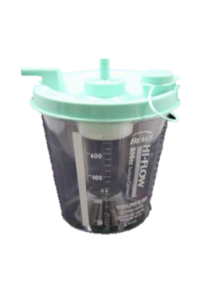
- Function: It is used for aspiration of foreign bodies (sputum) in oral cavity,

nasal cavity and lungs.
- Specifications:
- Size: (L)375 × (W) 220 × (H) 250mm
- Maximum vacuum pressure: 560+/-3% mmHg
- Flow: > 40LPM/min
- Steps to Use:
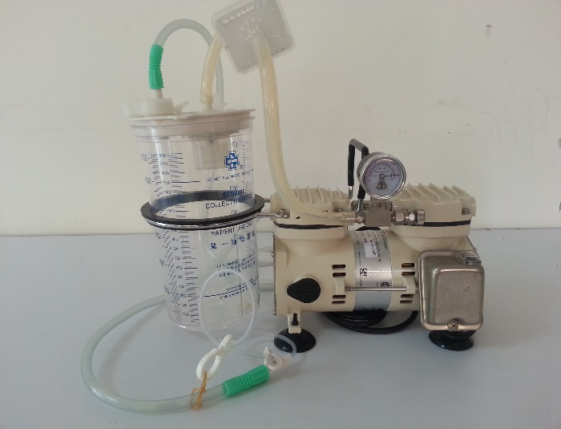
- Add 200c.c. of water into the sputum bottle (figure 1)
Fig. 2
Filter tube
Extended suction tube
Suction tube
to make the sputum adhere to the bottle less easily (do not add too much water, which will cause damage to the machine by inhaling water), and tighten the cap.
- Connect the extended suction tube to the suction inlet of the sputum bottle (Fig. 1, b), then connect the suction tube and install it on the sputum bottle (Fig. 1, a), as shown in Fig. 2.
- Insert the power plug into the power base and use 110V voltage.
- Push the switch to ON to turn on the power supply.
- Observe the pressure index of the vacuum gauge to adjust the appropriate suction and find the pressure adjustment valve knob. Clockwise direction is to increase attraction, counterclockwise direction is to reduce suction. (Pressure Settings - Adult: 100-200 mmHg).
- Put the sputum tube into the mouth and nose with a depth of 15-20 cm; autogenous cutting 12-14 cm. The suction time shall not exceed 15 seconds each time, and the suction should be performed every 1 to 2 minutes.
- After the use of the machine, turn OFF the power and unplug the power plug.

- Precautions:
- After the use of a sputum aspirator, the liquid in the sputum bottle must be washed clean for the next use (never let the liquid exceed half of the bottle body, so as not to cause the filter cotton blockage caused by the liquid withdrawal, resulting in machine failure, unable to sputum again).
- If the check valve in the cap of sputum bottle falls off during cleaning, please put it back in the original place.
- When you do not use the machine or clean the machine, you must first unplug the power plug from the socket.
- Please always pay attention to whether there is inhaled water in the nozzle of suction port and sputum extractor. If the moisture has been inhaled, please send it to repair as soon as possible in order to prevent damage to the machine.
- Please wipe the fuselage with a slightly wet cloth every 2 or 3 days to maintain the cleanliness of the machine.
- Do not place the machine near the water, fire, corner of the table and places easily accessible to children.
- Machine exterior: wipe with clean cloth with 1:100 diluted bleaching water.
- Collection bottle: Clean drainage bottles at least once a day. When the volume of liquid collected exceeds 2/3 of the bottle, it should be cleaned with soapy water. Disinfection should be carried out every three days according to the following methods:
- Soak in 75% alcohol for 30 minutes and rinse off.
- Dilute 10 times with household bleaching water (3%) and rinse out after soaking for 30 minutes.
- If the machine is damaged due to improper use, please find the manufacturer to repair or contact our center to find the manufacturer to repair (compensation is required according to the price).

