Chiayi County Assistive Device Resources Center
Instruction for Oxygen Generator
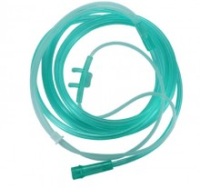
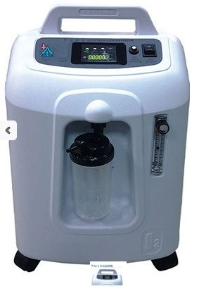
- Function: oxygen generator = oxygen concentrator = oxygen collector. Oxygen generator is to filter out 90% to 95% of the oxygen in the air through the inside parts of the machine to provide the oxygen for the patients with low blood oxygen concentration.
- Specifications:
- Size: 380×318×564
- Total weight: 15.1kg

- General type: 6L

Extended oxygen tube
Humidifying cup

- How to Use:
- The plug should be plugged into a 110V socket.
- Add 100~150cc of distilled or pure water (about 2/3 full of the bottle) to the humidifying cup.
- Put one end of oxygen nasal tube at the nozzle of humidifying cup and adjust oxygen flow according to doctor’s advice and patient’s condition.
- When the power is turned on, the buzzing sound (stop after about 10 seconds) and the power indicator light are on, the power is on and the machine is in operation.

- Precautions:
- When you turn it on, the alarm will make three short sounds of beeps, which is the protective and safety device of the machine, indicating the pressure is not stable and this is the normal phenomenon when the machine is started.
- When restarting the machine after shutdown, there must be an interval of 2 minutes. If the safety switch jumps, press down the safety switch before starting. If you turn it on and off immediately, it will easily cause machine failure.
- Do not connect the plug to the socket (220/60hz) used by the air conditioner to prevent the machine from burning and the wire from discharging. And please use a socket independently, do not share the same socket with other electrical appliances, in order to avoid insufficient voltage.
- Please notice whether the switch is in the OFF position before plugging the plug.
- When a child is playing with a machine and causes unsteady voltage, the protective device of the machine, the resistance current, will automatically cut off the power supply, and the warning device will also produce beep sounds shortly. Please put the power switch in the OFF position and restart it 5 minutes later.
- If the extended tube or nasal tube is pressed or broken, which causes pressure instability and gas cannot flow smoothly, it will also trigger a beep sound, please cut off the power supply first, and then check whether the extended tube or nasal tube is broken or pressed. After all the check, start again within five minutes.
- The power supply used at home is 110V. If the socket voltage is unstable or the plug is loose, the alarm will also produce beep sounds. Please plug the plug in and start it.
- If the flowmeter is not turned on after the machine starts, it will also trigger beep sounds. At this time, please turn the flowmeter on the indicated flow scale and use it.
- The long continual beep sound of the warming (if any) indicates the overload or other failure of the machine. Please turn off the machine and restart it five minutes later. Please contact the manufacturer for maintenance if the failure cannot be resolved three times in a row.
- Consumables update: oxygen produced by the oxygen generator is dry and must be moistened by the “humidifying cup” before being supplied to patients. And oxygen must be delivered to patients with the assistance of “oxygen nasal tube”, “oxygen extended tube”, “oxygen mask”, etc. All of the above (in “”) are consumables. It is recommended that they be renewed once every 1-3 months, because “moisture”+ “oxygen” = “breeding ground for bacteria”. Maintain 1/3 to 1/2 cup of distilled water in the humidifying cup. Distilled water needs to be updated every week. Clean the humidifying cup when you update distilled water.

